Specific Learning Difficulties: What Teachers Need to Know
Diana Hudson London: Jessica Kingsley Publishers, 2016 250 pp. £12.99 ISBN 978 1 84905 590 1

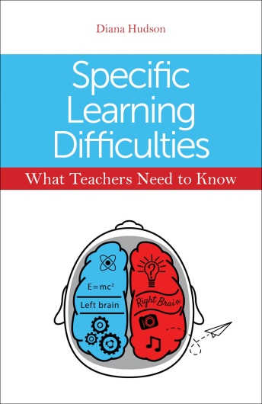

This paperback is an ideal book for those with responsibility for special needs, but can also provide some useful ideas for anyone working in a learning environment. Written by a classroom practitioner, this book should be on the shelf of every staffroom in my opinion. No matter how many training sessions you have attended on specific learning difficulties (SpLDs), this is one of the best resources I have come across. Diana Hudson has created a clear, concise guide packed with practical suggestions for approaching teaching pupils with learning difficulties.
Chapter by chapter she deals with each difficulty, detailing what the difficulty is, how to spot pupils with that condition, common indicators, common strengths, how you can help in the classroom, and individual help, before summarising the key points. The book is then completed with sections on organisation and exam help, again packed with useful suggestions. The common-sense approach to pupils with learning difficulties encourages the reader to take a positive approach to these pupils in order to help them achieve their potential.
I would highly recommend this book to anyone who deals with SpLDs. It is an invaluable resource setting out strategies, guidance and advice. I have found it enormously helpful in refreshing my approach to SpLDs within the classroom, and will continue to reach for it again and again.
Kate Cree

